**Workshop Details**

* Organizer: Universiti Sains Islam Malaysia (USIM)
* Topics covered:
  + Internet of Things (IoT)
  + Tinkercad Simulations
  + ESP8266 and Arduino IDE
  + Node-RED

**Getting Started**

We need to install the following:

1. **Arduino IDE (Software)**
2. **Install Driver for ESP8266**
3. **Node-RED (Software)**

**Step-by-Step Installation:**

1. **Arduino IDE (Software)**

**Step 1a: Download and install Arduino IDE**

Go to the following website: <https://www.arduino.cc/en/software>

Download and install (either *Windows Win 10 64bit* or *Window MSI installer*)

**Step 1b: After the completion of Arduino IDE software installation, we need to do setup for ESP8266:**

**Now do the following to install ESP8266 add-on in Arduino IDE**

To use the ESP8266 board with your Arduino IDE, follow these next instructions:

* 1. **Open Preferences:** In your Arduino IDE, go to File > Preferences.
  2. **Enter Board Manager URL:** Enter <http://arduino.esp8266.com/stable/package_esp8266com_index.json>  into the “Additional Boards Manager URLs” field as shown in the figure below. Then, click the “OK” button:

[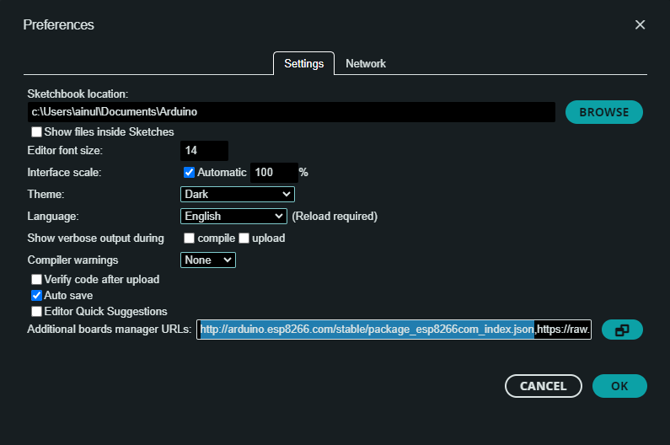](https://github.com/ainul21/IEEE-STEM-Program/blob/main/Documentation/media/preferences_arduino.png)

* 1. **Open Boards Manager:** Go to Tools > Board > Boards Manager…

[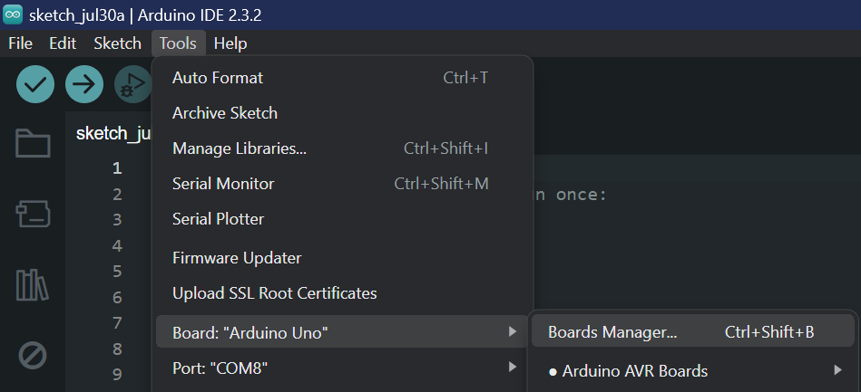](https://github.com/ainul21/IEEE-STEM-Program/blob/main/Documentation/media/boards_manager.png)

* 1. **Install ESP8266 Board:** Search for ESP8266 and press the install button for the “ESP8266 by ESP8266 Community”:

[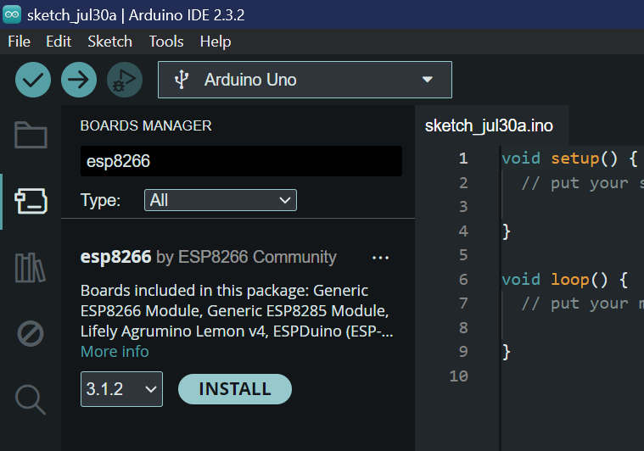](https://github.com/ainul21/IEEE-STEM-Program/blob/main/Documentation/media/install_board.png)

That’s it. It should be installed after a few seconds.

[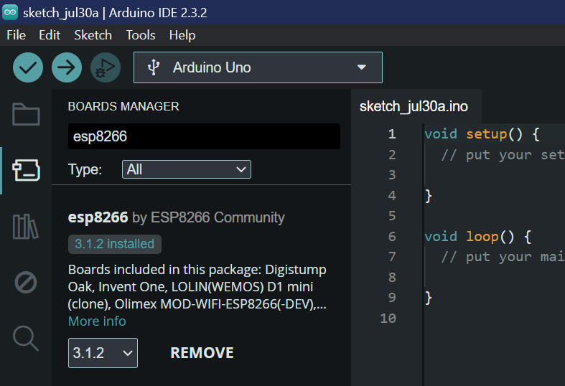](https://github.com/ainul21/IEEE-STEM-Program/blob/main/Documentation/media/installed.png)

**2. Install Driver for ESP8266**

**Installing CP210x USB to UART Bridge VCP Drivers (Windows PC)**

Start by downloading the [CP210x USB Drivers](https://www.silabs.com/developers/usb-to-uart-bridge-vcp-drivers?tab=downloads) from the official website. If you are on a Windows PC, you need to download the CP210x Windows Drivers folder highlighted in the image below.

URL: <https://www.silabs.com/developers/usb-to-uart-bridge-vcp-drivers?tab=downloads>

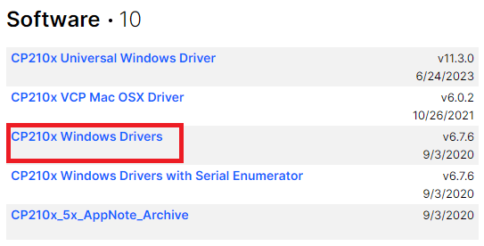

After downloading the CP210x Windows Drivers, right-click the folder and unzip the installation files.

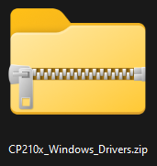

Open the unzipped folder and double-click the *CP210xVCPInstaller_x64.exe* file to start the installation process.

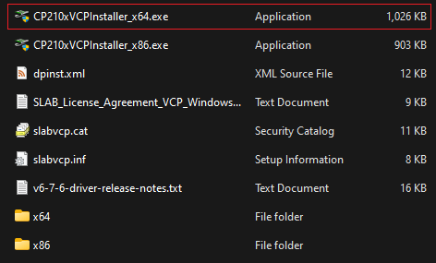

Follow the installation wizard, click the “Next” button, and agree with the terms of use to complete the installation process.

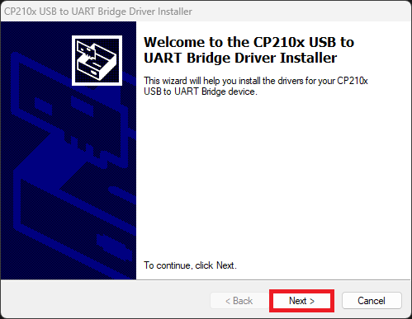

The CP210x USB drivers have been installed successfully.

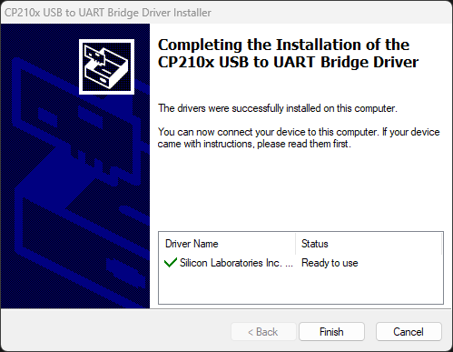

**Testing the CP210x USB Drivers**

Click the search bar.

Windows PC Search bar

Search for “Device Manager” and open the control panel:

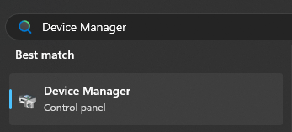

Having an ESP32/ESP8266 board connected to your Windows PC with a USB cable, under the “**Ports**” section you should see a device “Silicon Labs CP210x USB to UART Bridge (COM5)” (or with a different COM port number).

To program the ESP32/ESP8266 board with Arduino IDE, remember the COM port number, in our case it’s 5, COM5.

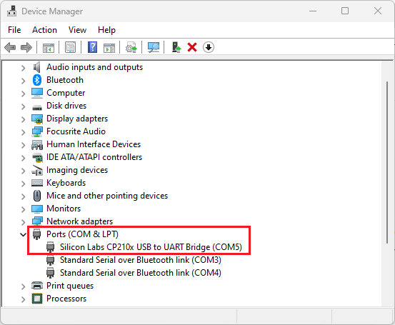

In the Arduino IDE, select your ESP32/ESP8266 board COMX Port, as shown earlier. Ours is COM5 Serial Port (USB).

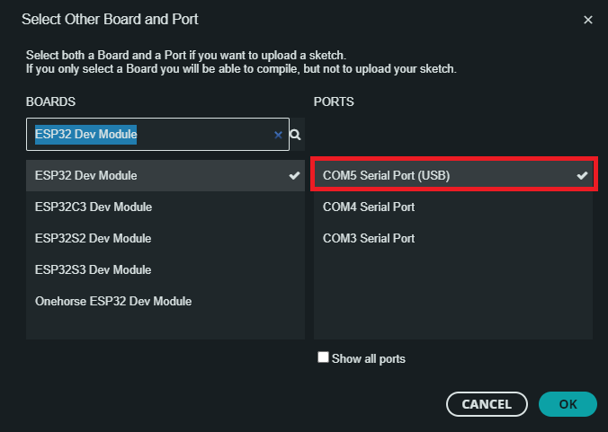

That’s it! You should now be able to see the COMX Serial Port of the ESP32/ESP8266 in Arduino IDE. You can upload a new code to your ESP board to test it.

**3. Install Node-RED:**

Go to the following website: <https://nodered.org/docs/getting-started/windows>

Follow 3 Steps below (also describe in the website above)

1. Install Node.js

Download the latest LTS version of Node.js from the official [Node.js home page](https://nodejs.org/en/). It will offer you the best version for your system.

Run the downloaded MSI file. Installing Node.js requires local administrator rights; if you are not a local administrator, you will be prompted for an administrator password on install. Accept the defaults when installing. After installation completes, close any open command prompts and re-open to ensure new environment variables are picked up.

Once installed, open a command prompt and run the following command to ensure Node.js and npm are installed correctly.

Using Powershell: node --version; npm --version

Using cmd: node --version && npm --version

You should receive back output that looks similar to:

v18.15.0

9.5.0

2. Install Node-RED

Installing Node-RED as a global module adds the command node-red to your system path. Execute the following at the command prompt:

npm install -g --unsafe-perm node-red

3. Run Node-RED

Once installed, you are ready to [run Node-RED](https://nodered.org/docs/getting-started/windows#running-on-windows).